**Devops Essentials:**

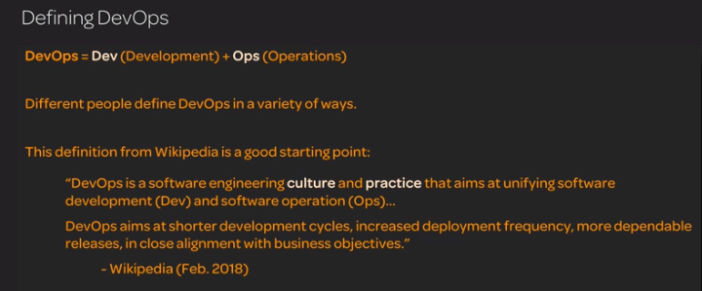

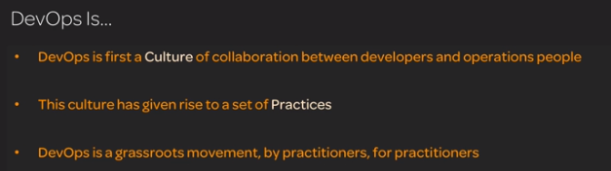

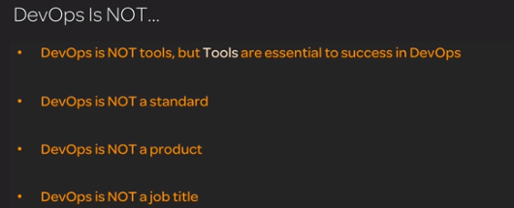

Agile method as previously we have waterfall model which is developing software as full and deploying takes months before delivery.

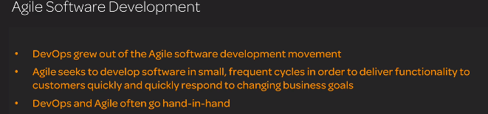

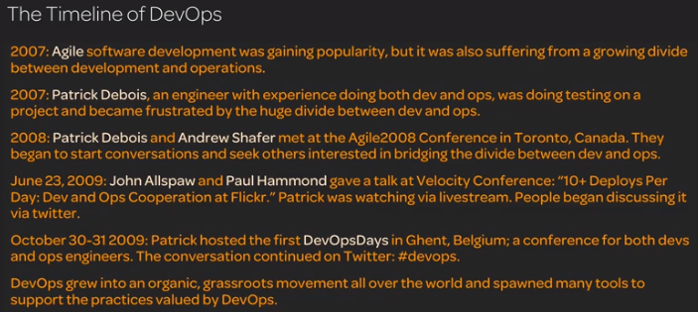

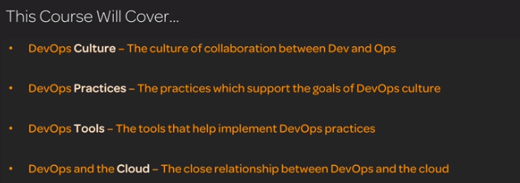

the primary goals of DevOps culture. In order to understand the purpose behind all of the tools and practices of DevOps, you need to know what it is that DevOps culture is trying to achieve. We will discuss how DevOps brings together the traditional goals of speed-of-delivery and stability. After this lesson, you should have an understanding of the goals and purpose of DevOps.

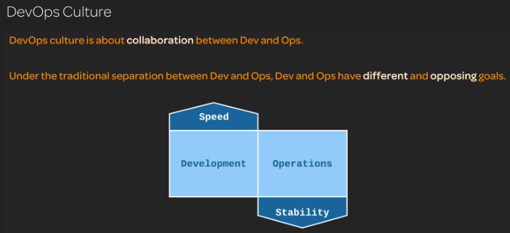

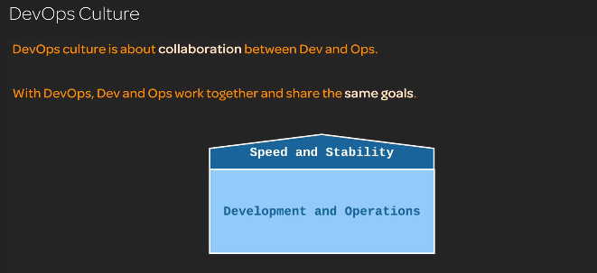

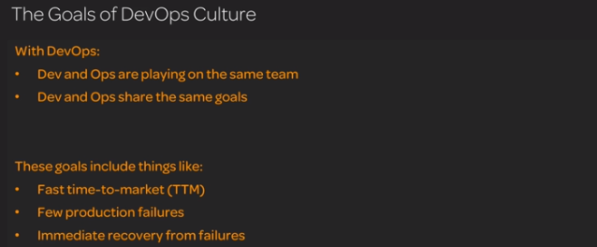

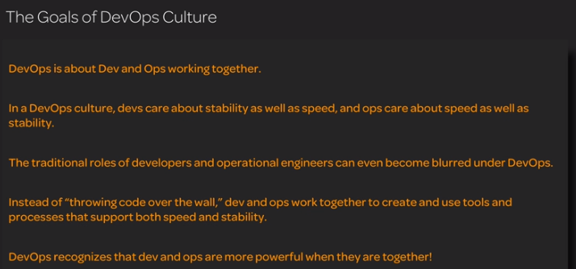

Traditionals vs devops

about how DevOps is different from a traditional IT culture. This will give you some insight into the purpose and benefits of DevOps culture. We will tell the story of a code change both within the world of traditional silos and within the world of DevOps. After this lesson, you should have an appreciation for DevOps as it differs from a traditional IT culture and some of the cultural problems which DevOps seeks to solve

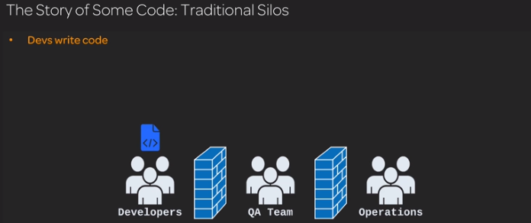

At this point developes sends code to QA and developsers are free and will think no responisblity regarding the code

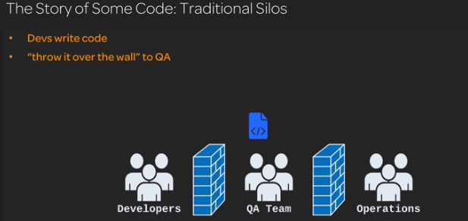

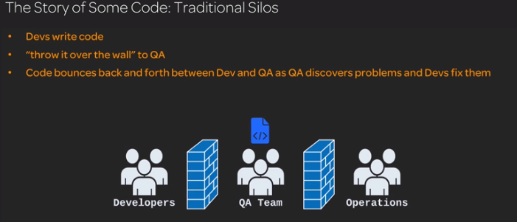

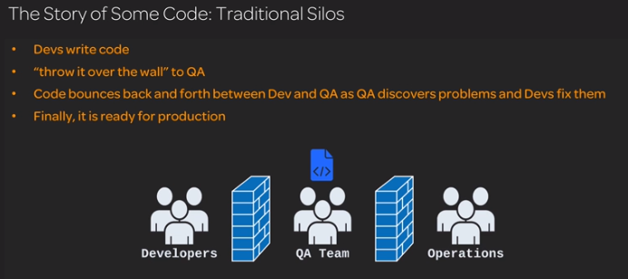

Here after QA test code successfully send code to operation but if any issue happends then production operation team send back to QA and developers here all will be saying every thing is ok but each group don’t have the actual visibility of the other teams work and what is going wrong from their end so productionwill be a block box to developers

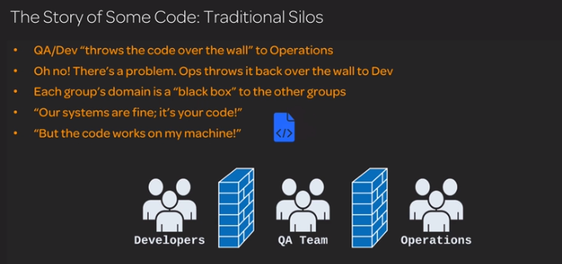

Due to work scope developers managers hold developers in involing in operation and same operation mangers will not invole in development and cant know actual issue. Two teams will be fighting against each other

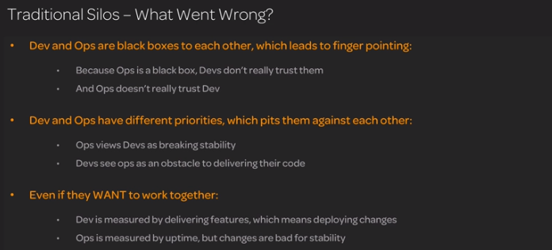

Time waste due to issues and locak of automation which means inconsitence and the same person who is building and deloying may not be available and if other peron deploying in wrong way agin it will be na issue

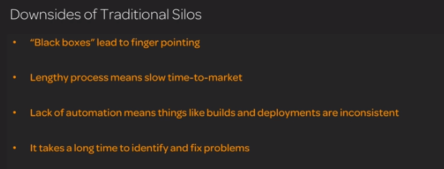

Devops method of approach:

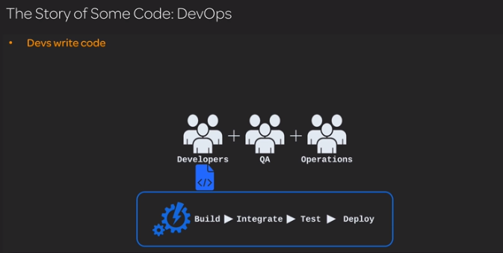

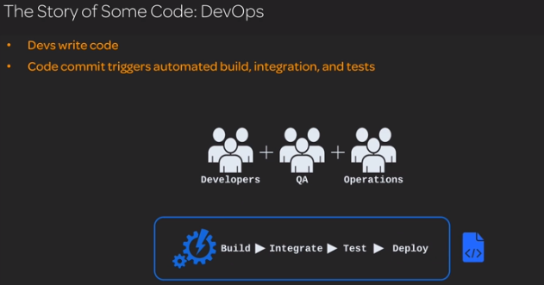

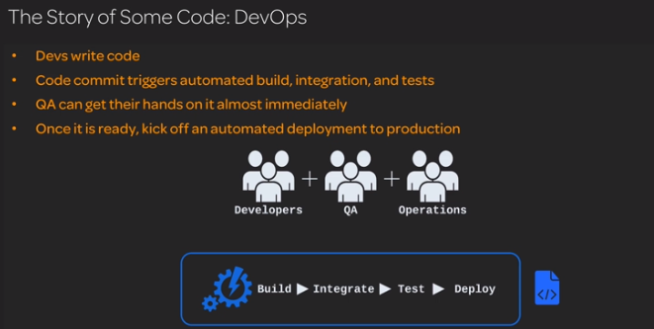

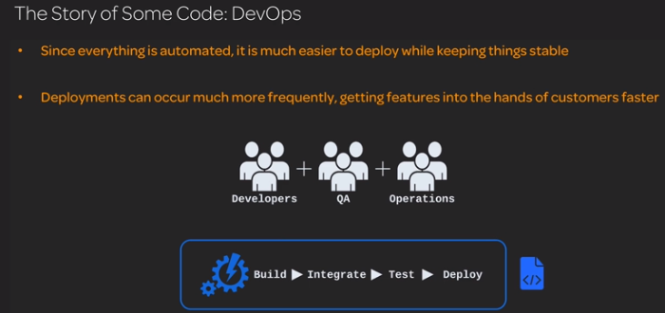

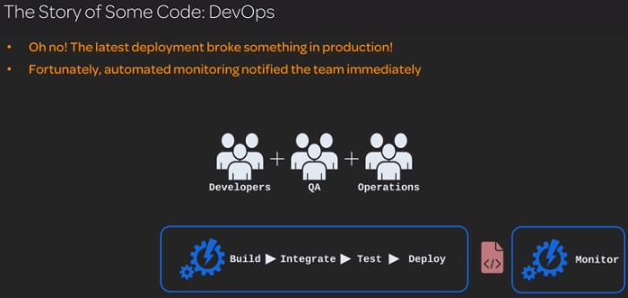

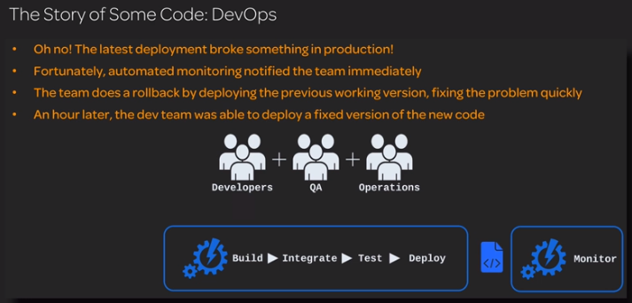

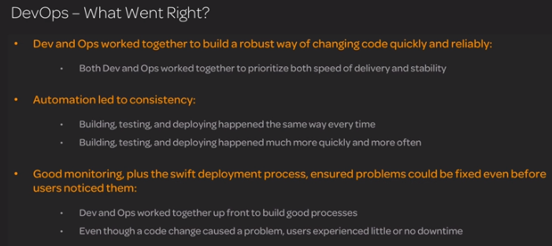

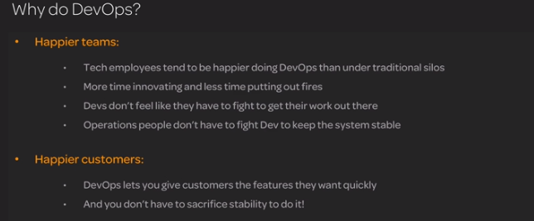

DevOps Concepts and Practices

****************************

Build Automation;

the concept of build automation. Build automation is an important part of any DevOps code pipeline, so you will likely need some basic knowledge of what build automation is. We will define build automation, talk about what it looks like in practice, and discuss some of its benefits. From this lesson, you should gain an understanding of what build automation is and how it can help you do DevOps

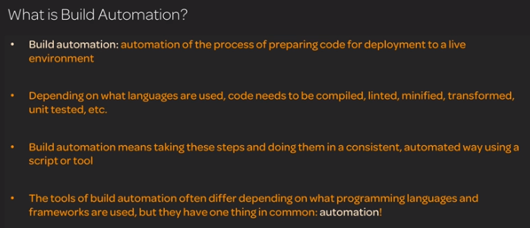

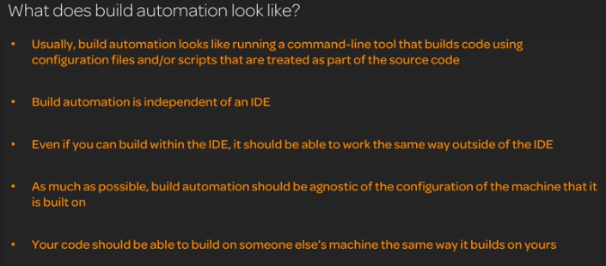

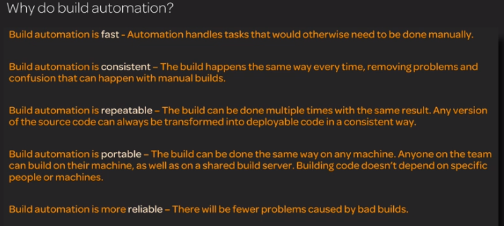

Continious Intergration:

the concept of continuous integration (CI). Continuous integration is a critical part of any DevOps pipeline. We will define continuous integration and talk about how it can benefit you. This lesson will give you a basic understanding of the concept of continuous integration.

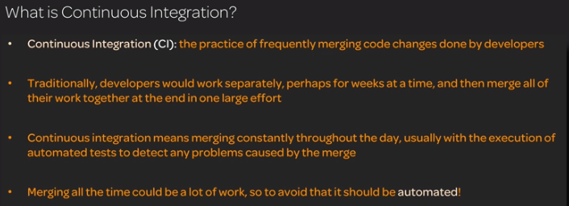

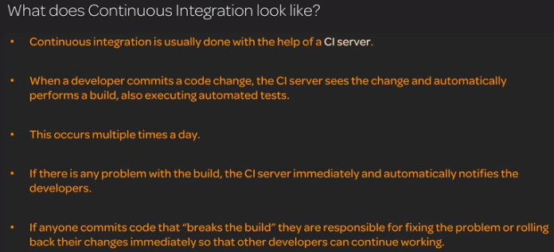

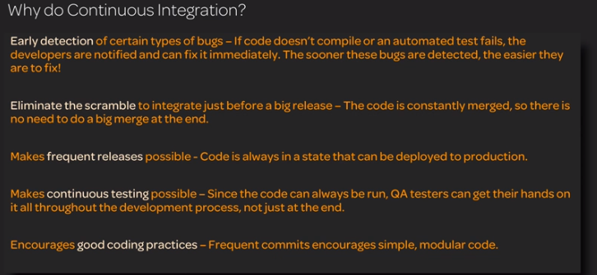

**Continuous Delivery and Continuous deployment:**

 continuous delivery and continuous deployment are introduced. Continuous delivery and continuous deployment are important parts of how code gets into production. We will define each of these terms, talk about the differences between them, and offer some insight into why you should use them. You should understand what continuous delivery and continuous deployment are after this lesson.

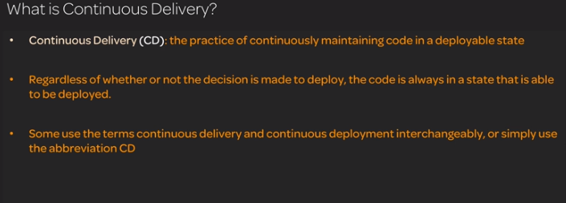

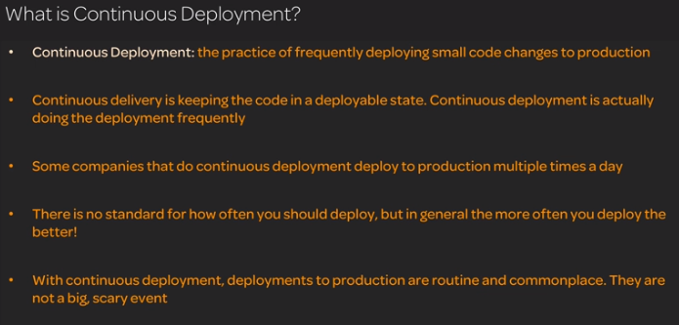

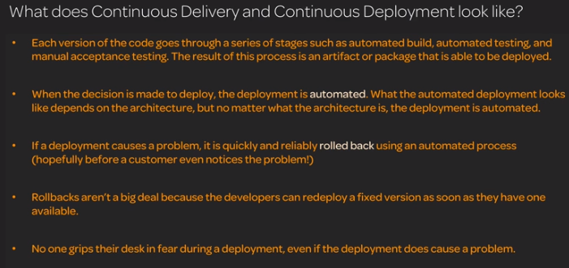

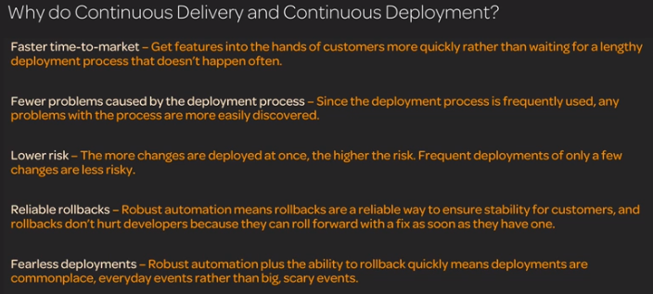

Infrastructiure as code:

the concept of infrastructure as code. IaaC is an important part of managing a successful DevOps infrastructure. We will talk about what IaaC is and what it looks like, as well as why you should use it. You should gain a basic understanding of IaaC from this lesson.

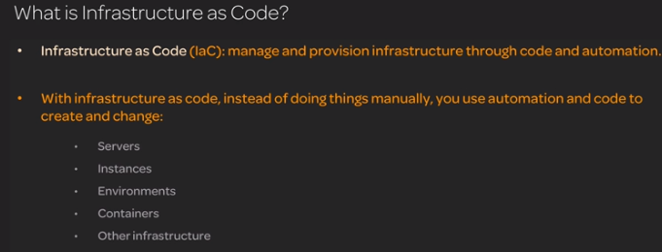

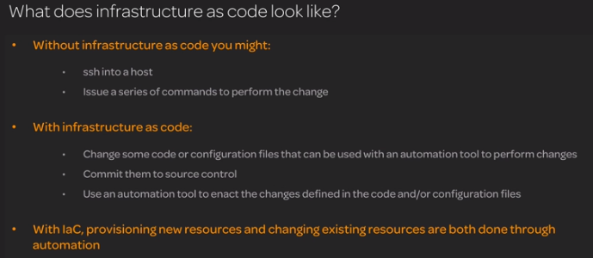

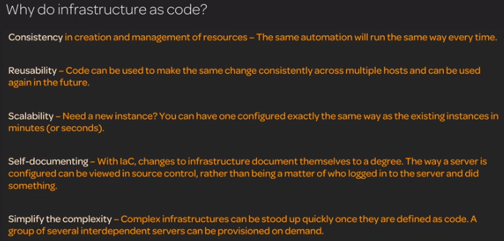

Configuration Management:

Configuration management is very useful when maintaining complex infrastructures. We will talk about what configuration management is and how it can benefit you.

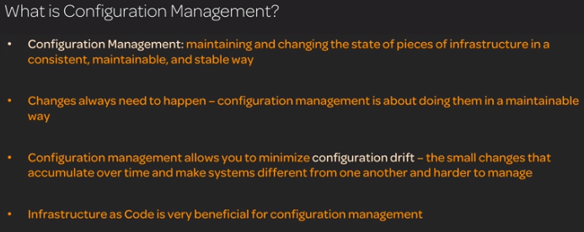

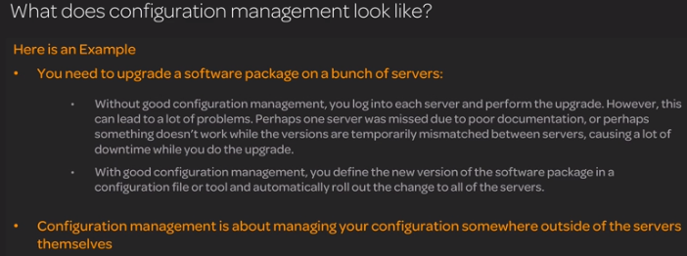

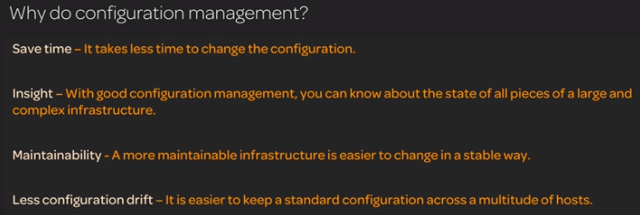

**Orchestration;**

server/container orchestration. Orchestration is a powerful tool that can help you achieve self-healing and auto-scaling systems that are resistant to load and production failures. We will define orchestration and talk about some of the ways it can benefit you.

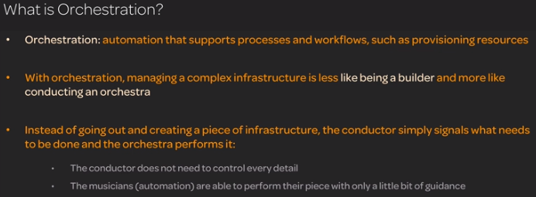

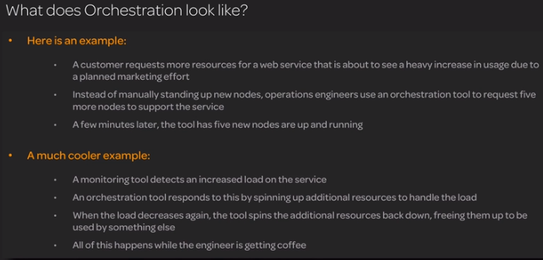

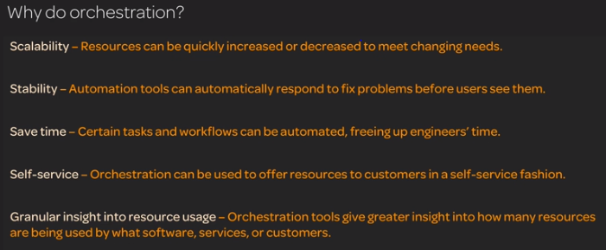

Monitoring:

 Monitoring is essential in identifying and fixing problems quickly, which is even more important when problems can be caused by the fast speed of delivery that DevOps seeks to achieve. We will define monitoring and discuss what it looks like in practice. From this lesson, you should gain a basic understanding of the concept of monitoring and its benefits.

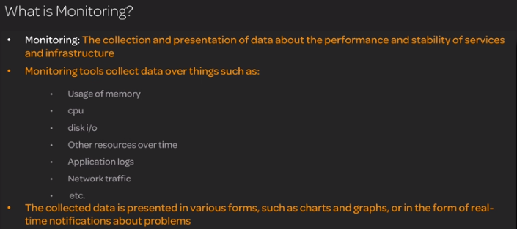

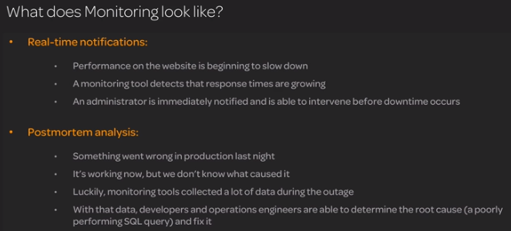

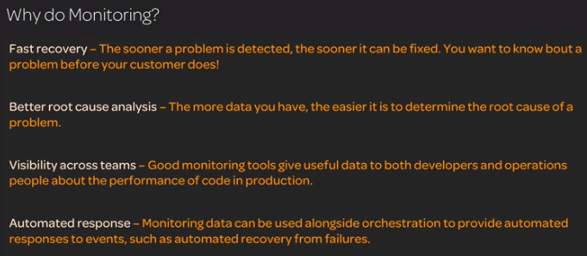

Microservices:

Microservices are a useful way to keep complex applications organized and maintainable. We will define the concept of microservices and provide some insight into why you might want to use them.

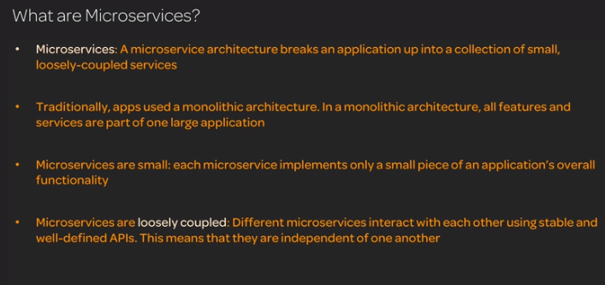

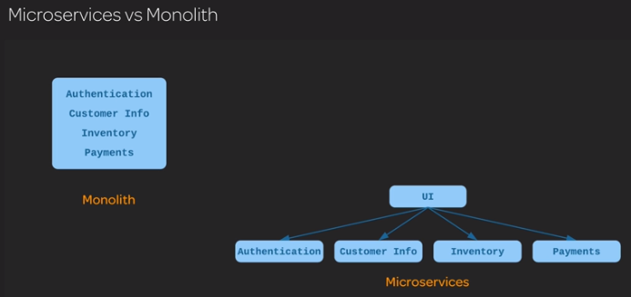

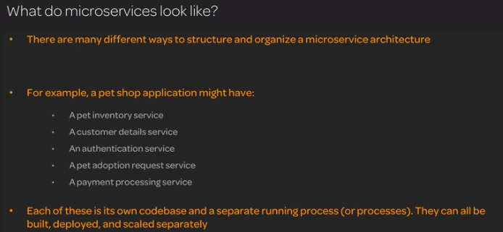

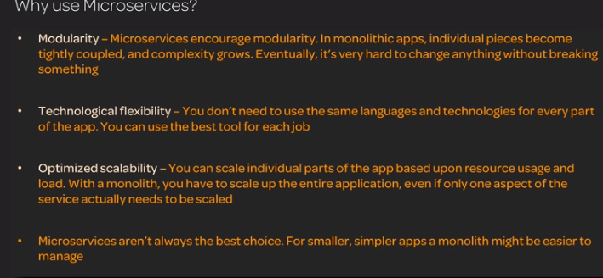

Devops Pipeline

#### DevOps Pipeline Walkthrough

This video will guide you through a hands-on demonstration of a DevOps pipeline. Many of the concepts related to DevOps are highly conceptual until you get a chance to see them in action. This video will show you step-by-step how to use the DevOps pipeline that has been prepared for this activity.

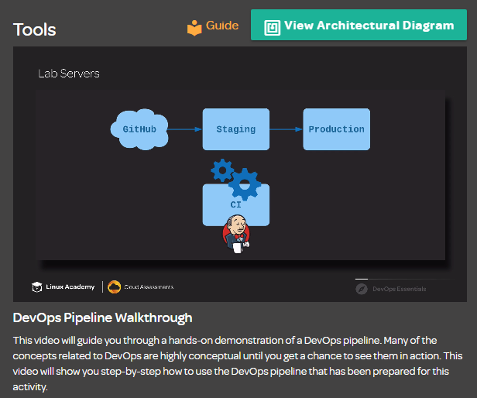

Instructions & Tasks

Note: You will need a GitHub.com account in order to complete this exercise.

In this Learning Activity, you will perform a series of deployments using a sample DevOps pipeline.

Sample application source in GitHub: <https://github.com/linuxacademy/devops-essentials-sample-app>

You will need the public IP Addresses that are listed here once your lab servers start up.

Follow the walkthrough video or the Learning Activity Guide to see a simple DevOps pipeline in action!

help

check_box_outline_blank

**Execute the initial deployment.**

help

check_box_outline_blank

**Run the "broken" deployment.**

help

check_box_outline_blank

**Roll back the broken deployment.**

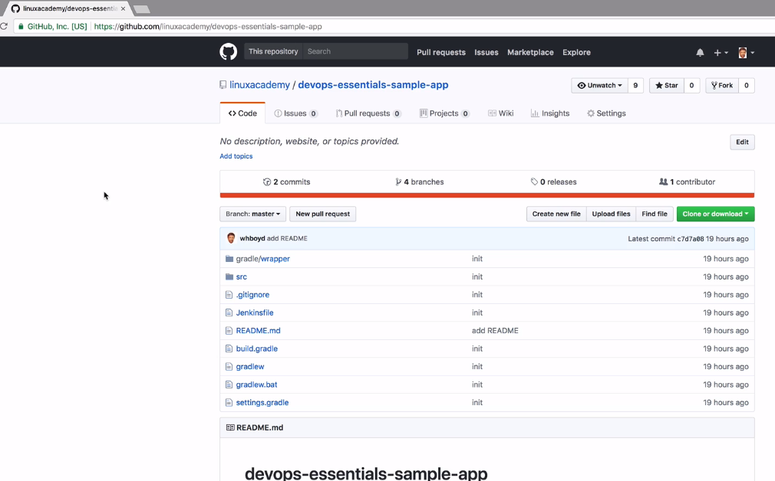

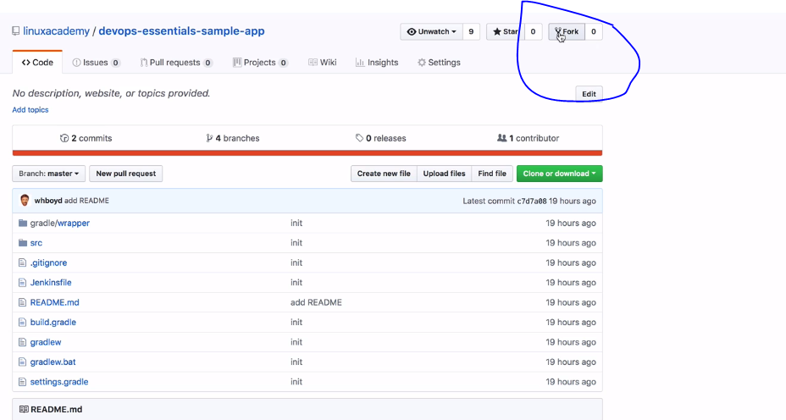

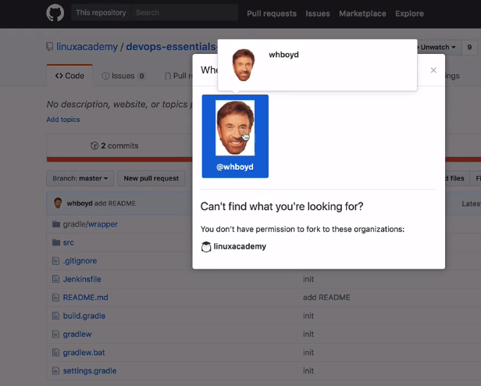

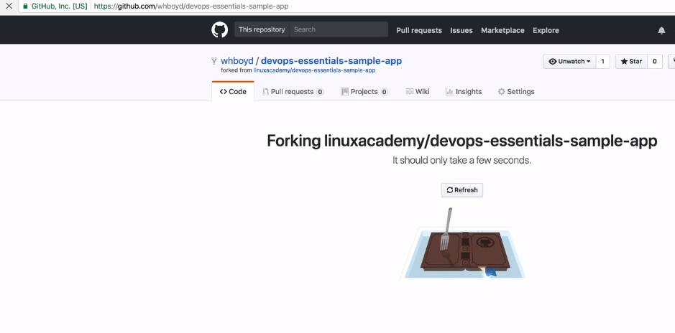

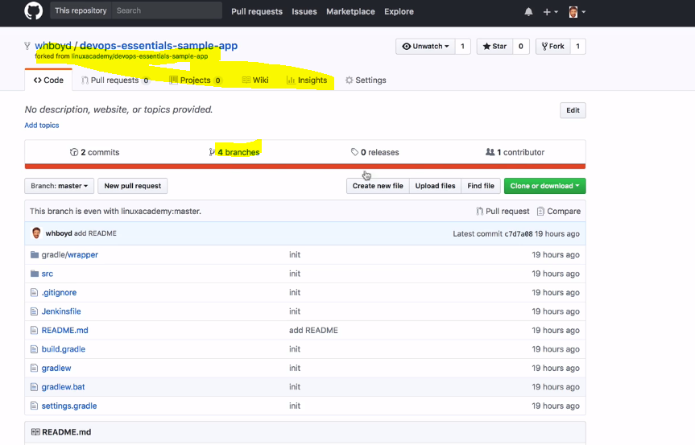

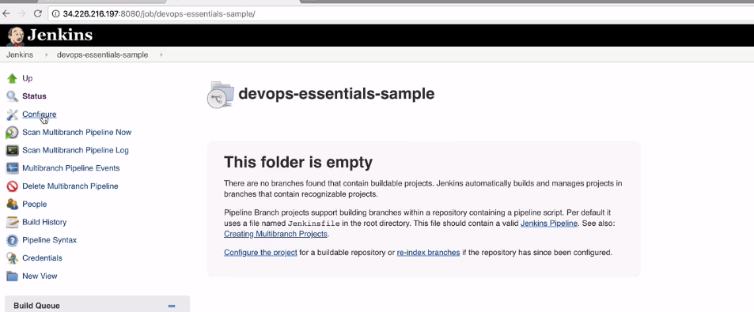

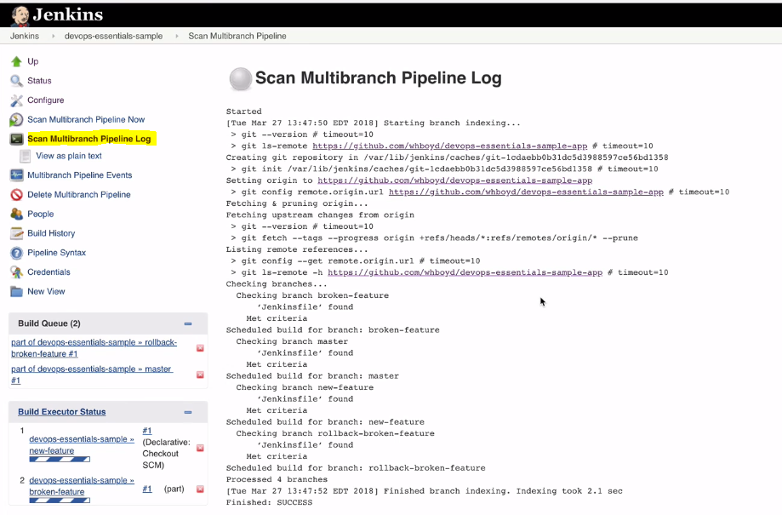

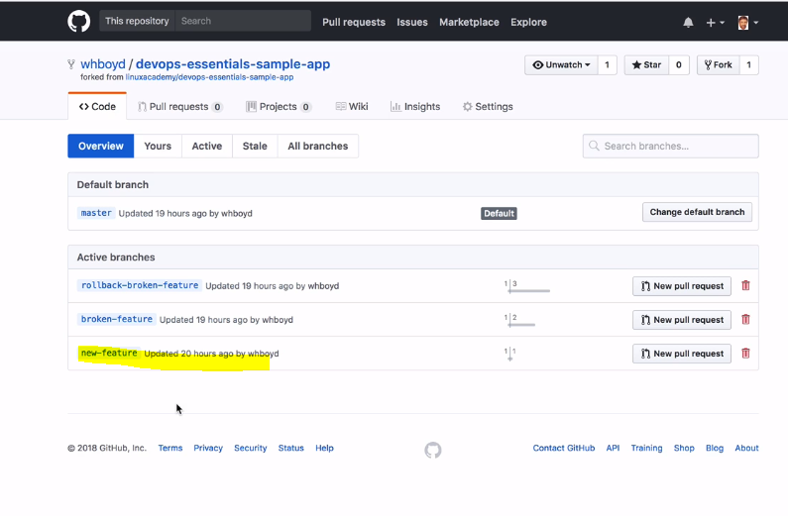

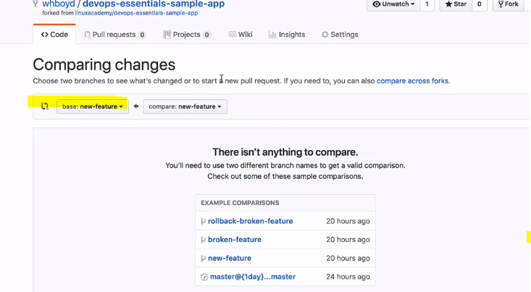

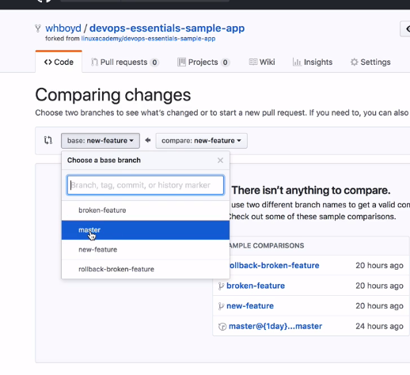

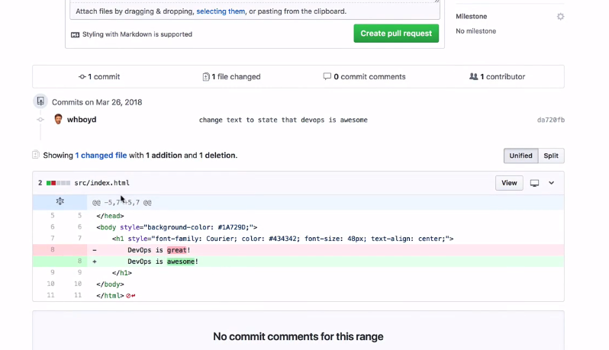

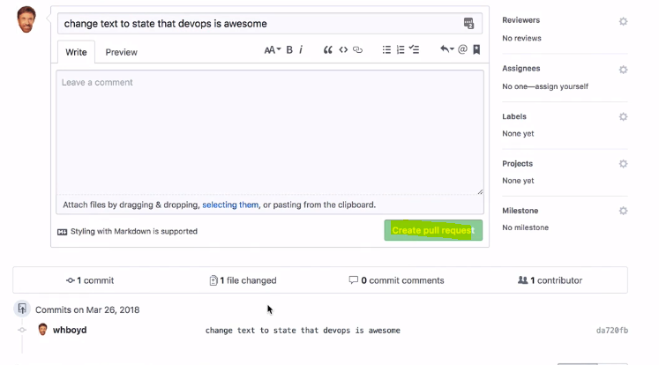

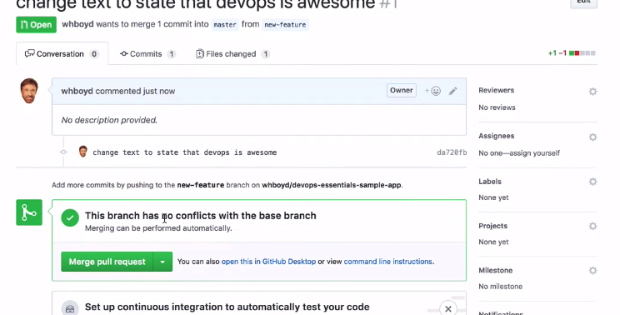

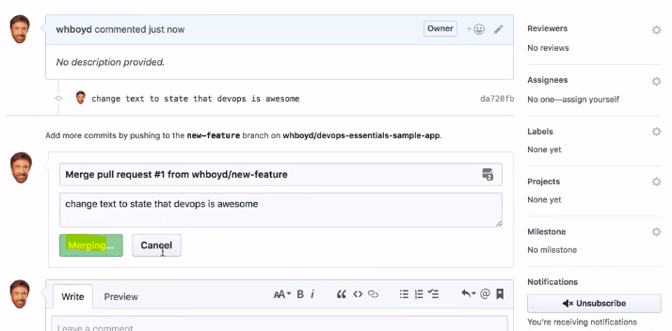

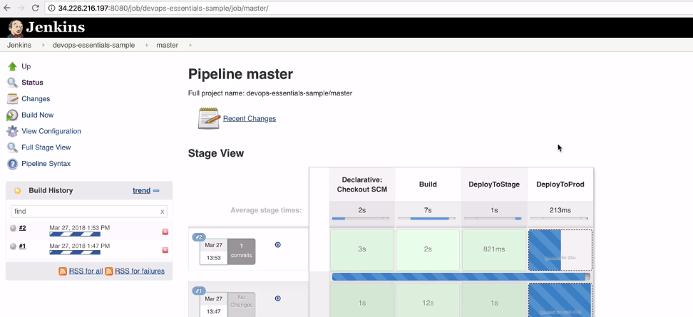

<http://54.162.24.0:8080/job/devops-essentials-sample/configure>;

CI Configration ;

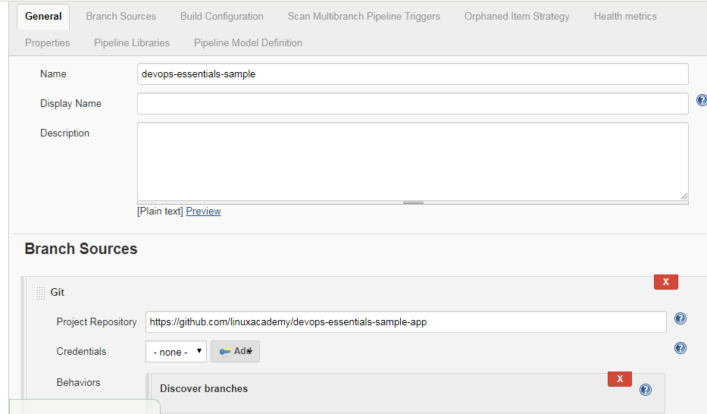

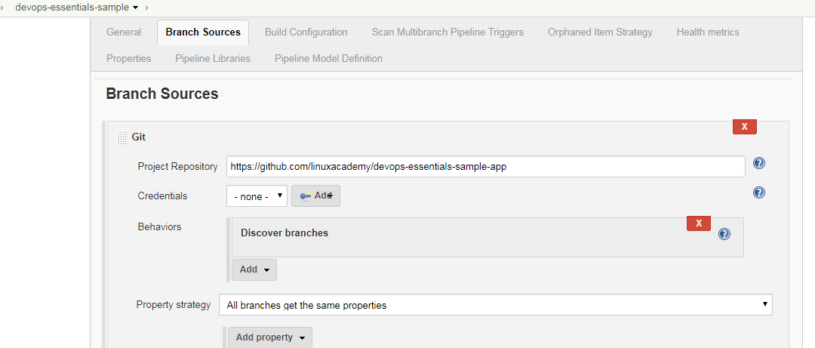

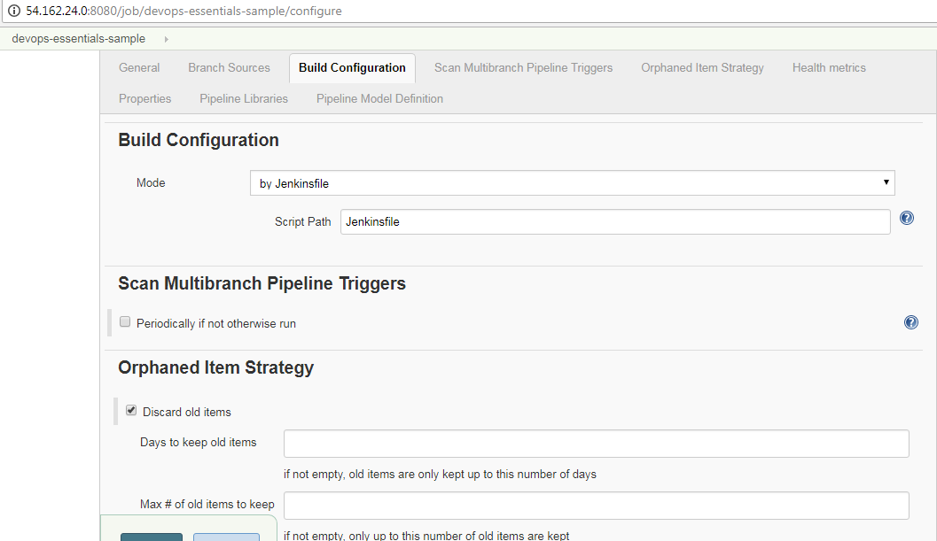

Devops Tools:

DevOps and provides some resources for learning about them. Tools are very important to DevOps, and you will need to know how to identify the tools you need. We will talk about the periodic table of DevOps tools from Xebia labs, which is a useful resource for finding and researching DevOps tools.

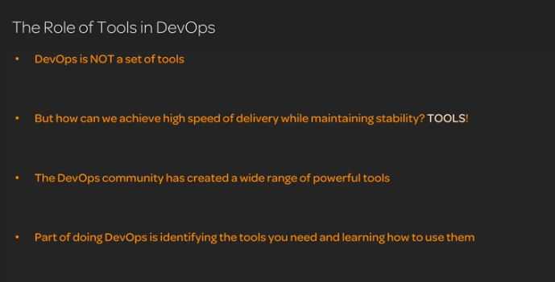

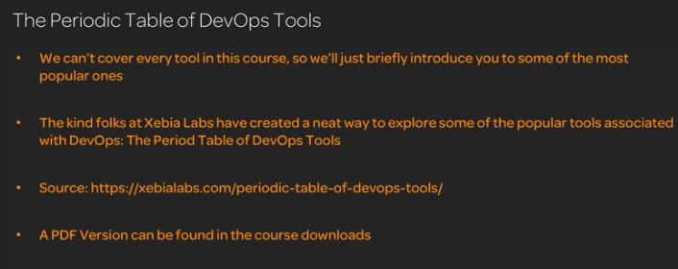

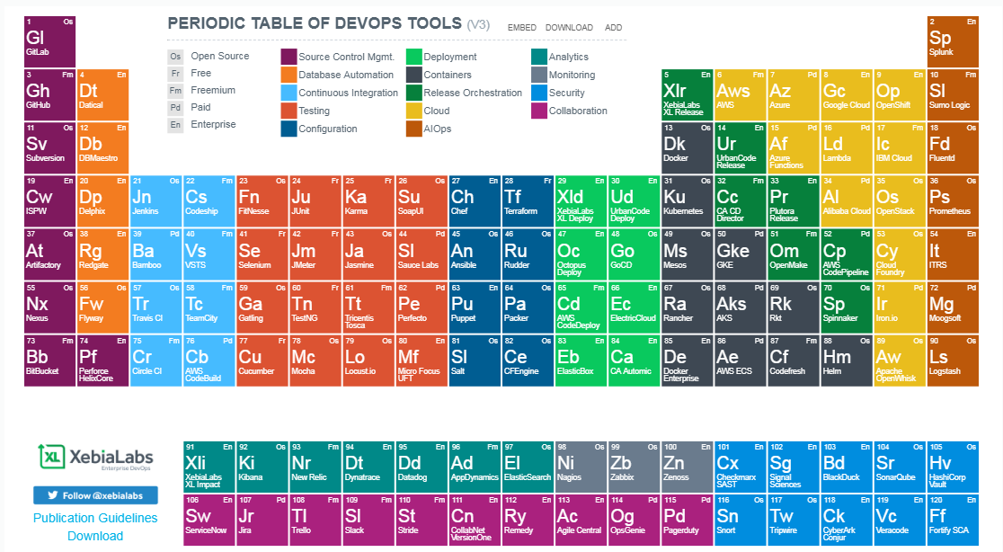

**build automation and CI**

build automation and CI. If you want to do build automation and CI, you will want to take advantage of some of the many tools that are available to you. We will discuss build automation tools such as Gradle, Grunt, and Maven as well as CI tools like Jenkins, TravisCI, and Bamboo. After this lesson, you should have a basic familiarity with a few of the tools that are available for build automation and CI.

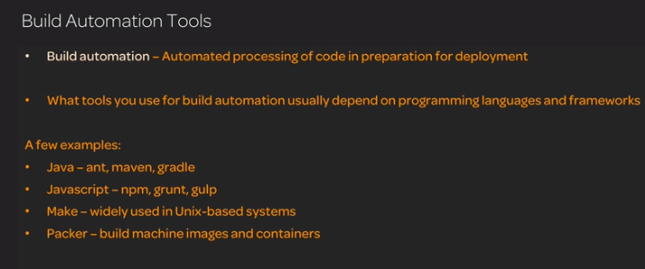

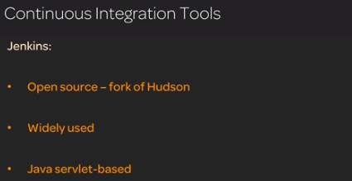

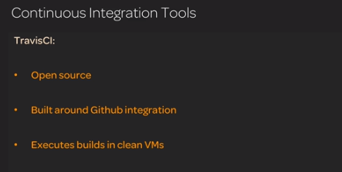

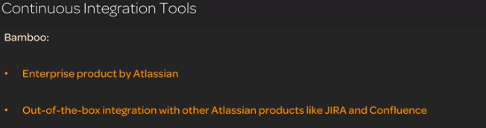

**Configuration management**

Configuration management is made much easier by the tools that are available. We will talk about Ansible, Puppet, Chef, and Salt. You should gain a basic understanding of what configuration management tools are as well as some familiarity with the major tools covered in this lesson.

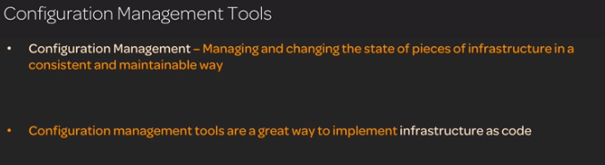

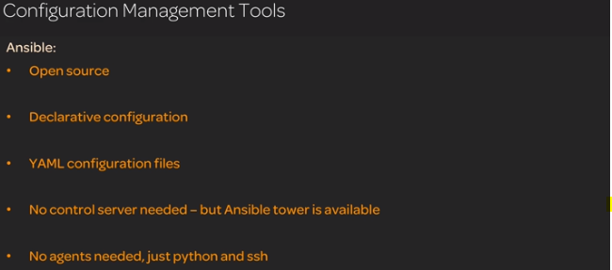

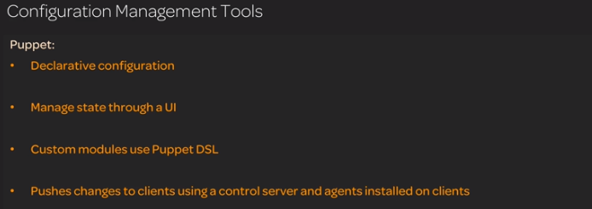

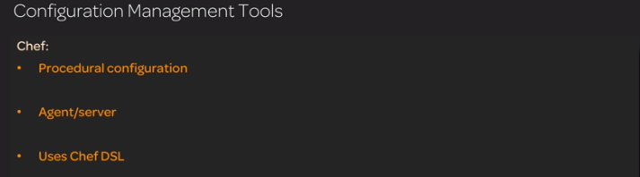

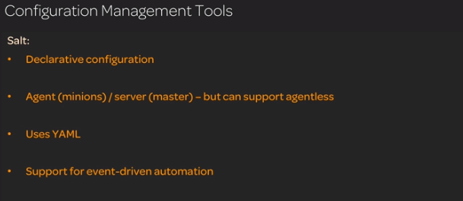

**Virtualization and containerization**

Virtualization is very powerful when it comes to doing DevOps. In some ways, containerization is even more powerful. You will need to have a basic understanding of the tools available in this space in order to make informed decisions about your DevOps infrastructure.

We will talk briefly about a few popular virtualization tools and then introduce Docker as we discuss the topic of containerization. You should gain from his lesson a basic understanding of virtualization and containerization as well as a basic familiarity with Docker.

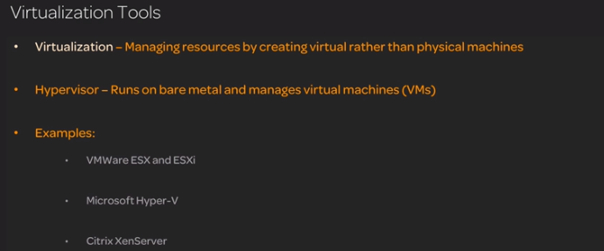

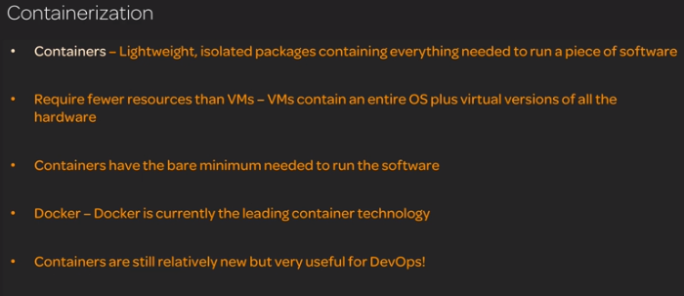

**Monitoring Tools**

Monitoring is a necessary part of success in DevOps, and you need to be familiar with the tools available. We will talk about a few major monitoring tools, such as SenSu, NewRelic, and AppDynamics. We will also introduce the concept of aggregation and analytics, and talk about Elastic Stack. From this lesson, you should gain a basic understanding of the types of monitoring tools that are available

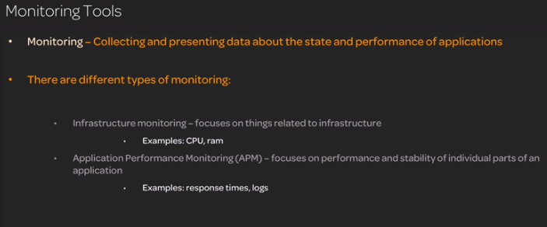

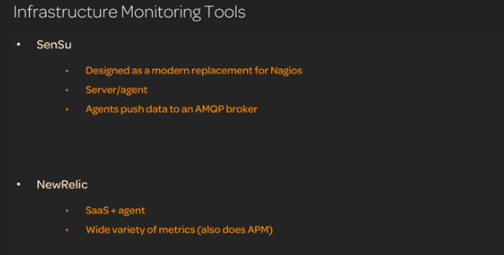

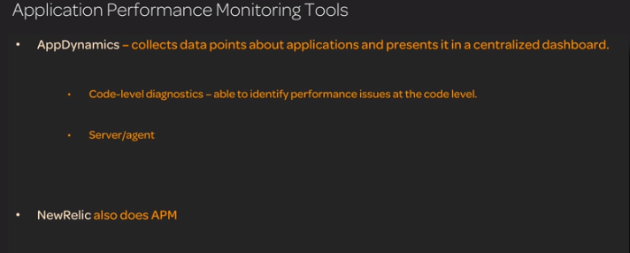

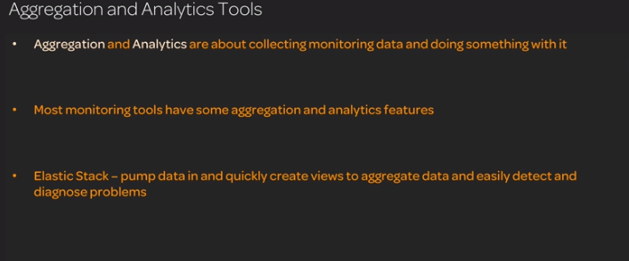

**Orchestration:**

Orchestration tools are a powerful way to achieve high stability in production. We will talk about a few of them, including docker swarm, zookeeper, kubernetes, and terraform. This lesson should give you a foundational

understanding of the types of tools that are available for doing orchestration.

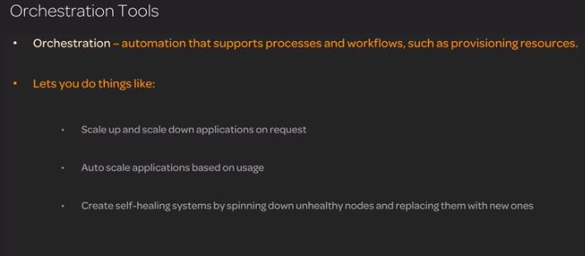

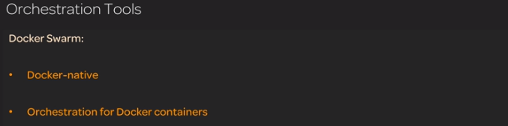

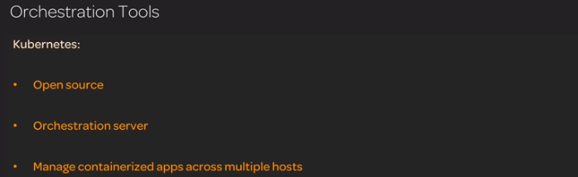

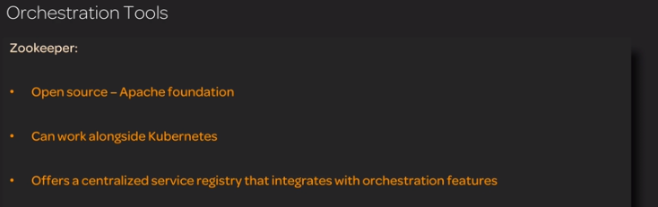

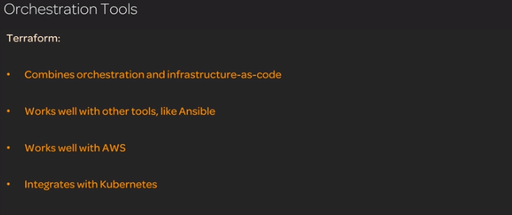

Devops and cloud;

DevOps is closely related to the cloud, and today it is necessary to understand the relationship between DevOps and the cloud in order to understand many cloud tools and concepts. We will talk about this relationship between DevOps and the cloud and talk about some of the different cloud platform architectures such as IaaS, PaaS, SaaS, and serverless. From this lesson, you should gain a basic understanding of cloud platforms and how they relate to DevOps

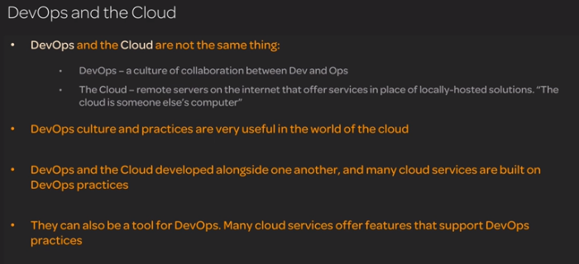

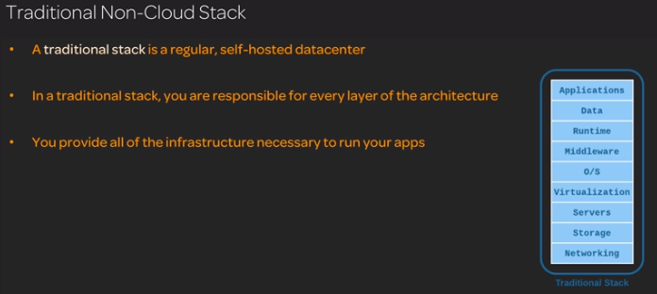

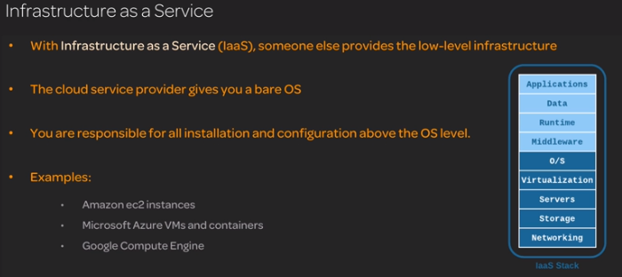

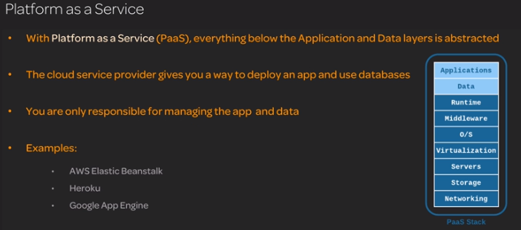

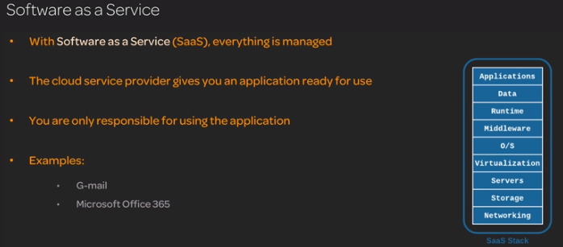

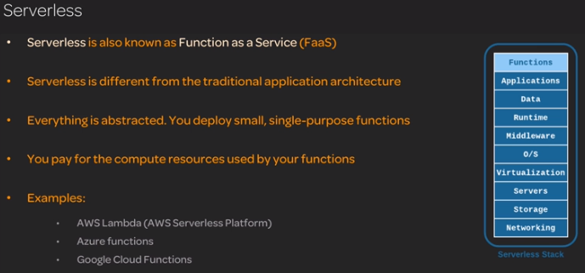

Google Cloud Platform that support DevOps. If you want to use Google Cloud Platform, you need to be aware of the DevOps-related features it offers. We will discuss some of the ways in which Google Cloud Platform supports DevOps. You should gain from this lesson a foundational understanding of the DevOps functionality offered within GCP.

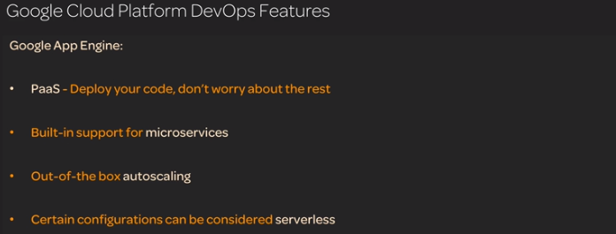

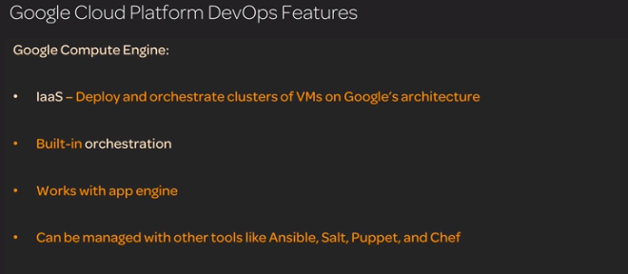

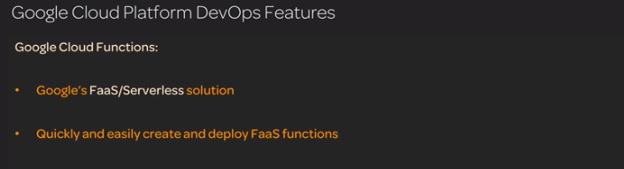

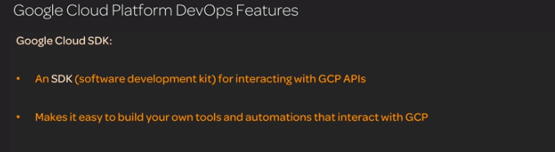

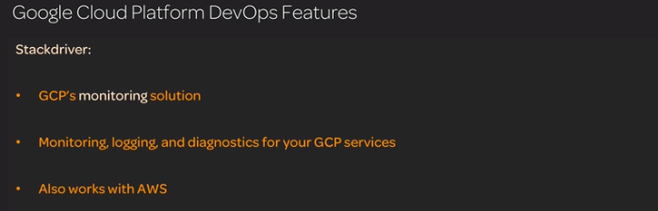

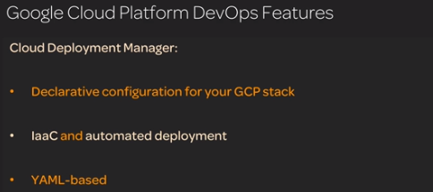

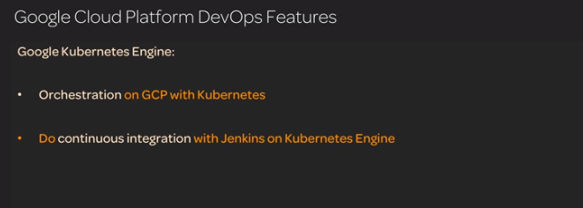

Microsoft Azure. If you use or are considering using Azure, you need to know how Azure can support you in doing DevOps. We will talk about some of the DevOps tools that Azure offers. You should gain a basic understanding of the various ways in which Microsoft supports DevOps on the Azure cloud platform.

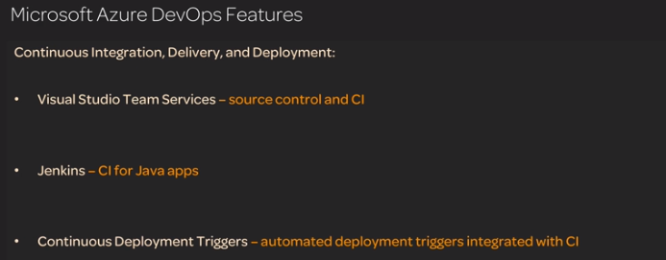

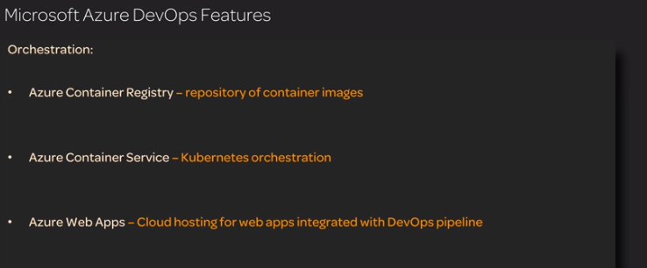

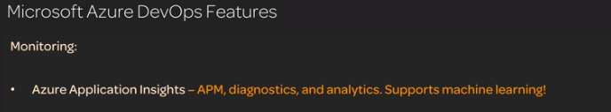

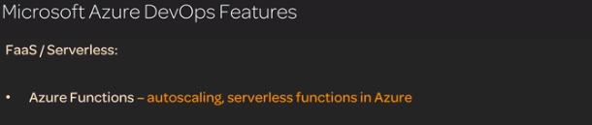

Amazon Web Services. If you want to do DevOps in the context of AWS, you should know about the DevOps features AWS provides. We will discuss a few of these features. This should give you a basic understanding of how AWS can support you in your DevOps journey.

